**PSG COLLEGE OF TECHNOLOGY, COIMBATORE – 641 004**

**Department of Applied Mathematics and Computational Sciences**

**M Sc SOFTWARE SYSTEMS – Semester IV**

**20XW48 – Web Designing Lab**

**PROBLEM SHEET 2 – Form Tags**

**NAME:SAI DINESH B**

**ROLL NO:20PW30**

**Forms**

Forms are used to get input from user. This problem sheet is for designing the forms. The exact design specification is also provided. Later the validation could be done using client side scripting code

1. Design a feedback form for a web site. Align the content as below.



<html>

<head><font style="arial" size="8" color="brown"><center>FEEDBACK</center></font></head>

<p><center>you can help us to improve our website by using the following form to let us to know what you think or what needs<br>to be changed</center></p>

<style>

textarea{

        overflow-y: scroll;

        height: 60px;

        width:200px;

        resize: none; /\* Remove this if you want the user to resize the textarea \*/

    }

</style>

<form>

<table align="center">

    <tr style="height:40px;">

        <td><label for="name:">NAME&ensp; &ensp; &ensp; &ensp;</label></td>

        <td><input name="name" type="text" style="width:200px;"></input>

    </tr>

    <tr style="height:40px;">

        <td><label for="name:">EMAIL&ensp; &ensp; &ensp; &ensp;</label></td>

        <td><input name="name" type="text" style="width:200px;"></input>

    </tr>

    <tr style="height:40px;">

        <td><label for="club">Are you a club member: &ensp; &ensp; &ensp; &ensp;</label></td>

        <td><input name="name" type="checkbox" style="width:40px;"></input>

    </tr>

    <tr style="border-bottom-width:100px;">

        <td><label for="club">your age: &ensp; &ensp; &ensp; &ensp;</label></td>

        <td><input name="name" type="radio" style="width:40px;"><=20</input></td>

        <tr>

            <td></td>

            <td><input name="name" type="radio" style="width:40px;">21-30</input></td>

        </tr>

        <tr>

            <td></td>

            <td><input name="name" type="radio" style="width:40px;">31-40</input></td>

        </tr>

        <tr>

            <td></td>

            <td><input name="name" type="radio" style="width:40px;">>40</input></td>

        </tr>

    </tr>

    <tr style="height:40px;">

        <td><label for="style">Your state:</label></td>

        <td><select style="width:200px;"><option>Tamil Nadu</option><option>Kerala</option></select></td>

    </tr>

    <tr style="height:40px;">

        <td><label>How did you find our site</label></td>

        <td><select onfocus='this.size=3;' onblur='this.size=1;' onchange='this.size=1; this.blur();'><option>Web search</option><option>Link on another site</option><option>Told about it</option></select></td>

    </tr>

    <tr style="height:40px;">

        <td><label>Site suggestions</label></td>

        <td><textarea placeholder="Type your suggestion here"></textarea></td>

    </tr>

    <tr style="height:40px;">

        <td><label>Other Comments:</label></td>

        <td><textarea placeholder="Additional comments here"></textarea></td>

    </tr>

    <tr style="height:40px;">

        <td colspan="2" align="center"><input type="button" style="width:70px; background-color:#0d6975; color:white;" value="SUBMIT"></input>

            <input type="button" style="width:70px; background-color:#0d6975; color:white;" value="RESET"></input></td>

    </tr>

</table>

</form>

</html>

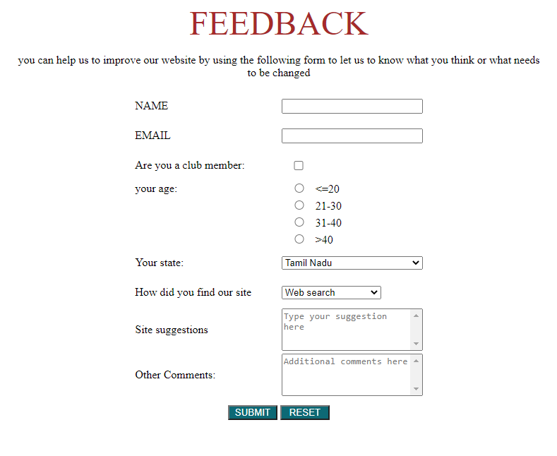

1. Design a customer feedback form for an organization web site. Use tables to make the perfect alignment.

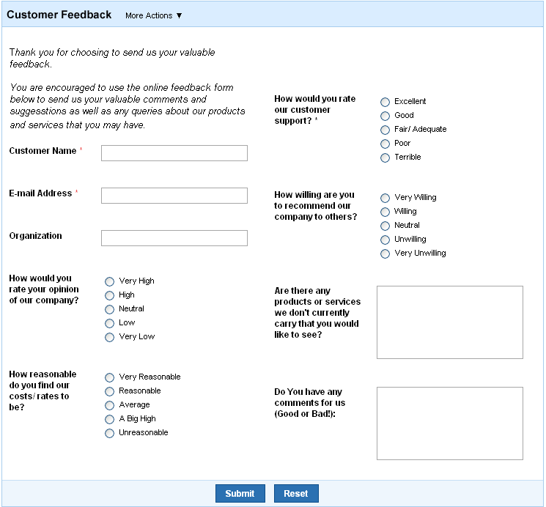

<html>

  <style>

***Table***{

      border:1px solid blue***;***

      border-collapse: :collapse***;***

    }

  </style>

<head>

<title>FEEDBACK</title>

</head>

<body>

<table align="center">

<form>

  <tr *style*="background-color: lightblue;">

<td *colspan*=4>Customer feedback **&nbsp;**

    <label *for*="lang"></label>

      <select *style*="background-color: lightblue;" *name*="More actions" *id*="More actions">

        <option *value*="More actions">More actions</option>

      </select>

    </td>

</tr>

<tr>

<td *colspan*=3>Thank you for choosing to send us your<br>valuable feedback</td>

</tr>

<tr>

<td *colspan*=2 *valign*="top">You are encouraged to use the online feedback form<br>below us to send us your valuable comments and<br>suggestions as well as any queries about our products<br>and services you may have.<br><br>

<p>Customer Name<font *color*="red">\*<font>**&emsp;**<input *type*="Text"></p></td>

<td *valign*="top">How would you rate<br>our customer<br>support?<font *color*="red">\*<font></td>

<td>

<p><input *type*="radio" *name*="rate">Excellent</p>

<p><input *type*="radio" *name*="rate">Good</p>

<p><input *type*="radio" *name*="rate">Fair/Adequate</p>

<p><input *type*="radio" *name*="rate">Poor</p>

<p><input *type*="radio" *name*="rate">Terrible</p>

</td>

</tr>

<tr>

<td *colspan*=2>

<br>

  <p>Email Address<font *color*="red">\*</font>**&ensp;&ensp;&ensp;&ensp;&ensp;**<input *type*="Text"></p>

<br><br><br>

<p>Organization**&ensp;&ensp;&ensp;&ensp;&ensp;&ensp;&ensp;**<input *type*="Text"></p>

</td>

<td *valign*="top"><br><br>How willing are you<br>to reccommend our<br>company to others?</td>

<td>

<p><br><br><input *type*="radio" *name*="rate">Very willing</p>

<p><input *type*="radio" *name*="rate">Willing</p>

<p><input *type*="radio" *name*="rate">Neutral</p>

<p><input *type*="radio" *name*="rate">Unwilling</p>

<p><input *type*="radio" *name*="rate">Very unwilling</p>

</td>

</tr>

<tr>

<td *valign*="top"><br><br>How would you<br>rate your opinion<br>of our company?</td>

<td>

<p><br><br><input *type*="radio" *name*="rate">Very high</p>

<p><input *type*="radio" *name*="rate">High</p>

<p><input *type*="radio" *name*="rate">Neutral</p>

<p><input *type*="radio" *name*="rate">Low</p>

<p><input *type*="radio" *name*="rate">Very Low</p>

</td>

<td *valign*="top"><br><br>Are there any<br>products or service<br>we don't currently<br>carry that you would<br>like to see?</td>

<td>

<textarea *rows*=7 *columns*=6></textarea>

</td>

</tr>

<tr>

<td *valign*="top"><br><br>How reasonable<br>do you find our<br>cost/rates to be?</td>

<td>

<p><br><br><input *type*="radio" *name*="rate">Very Reasonable</p>

<p><input *type*="radio" *name*="rate">Reasonable</p>

<p><input *type*="radio" *name*="rate">Average</p>

<p><input *type*="radio" *name*="rate">A Big High</p>

<p><input *type*="radio" *name*="rate">Unreasonable</p>

</td>

<td *valign*="top"><br><br>Do You have any<br>comments for us<br>(Good or Bad!):</td>

<td>

<textarea *rows*=7 *columns*=6></textarea>

</td>

</tr>

  <tr *style*="background-color: lightblue;">

    <td align="center" *colspan*="4">

      <button *type*="button" *style*="background-color: dodgerblue;">Submit</button>

      <button *type*="button" *style*="background-color: dodgerblue;">Reset</button>

    </td>

  </tr>

</form>

</table>

</body>

<html>

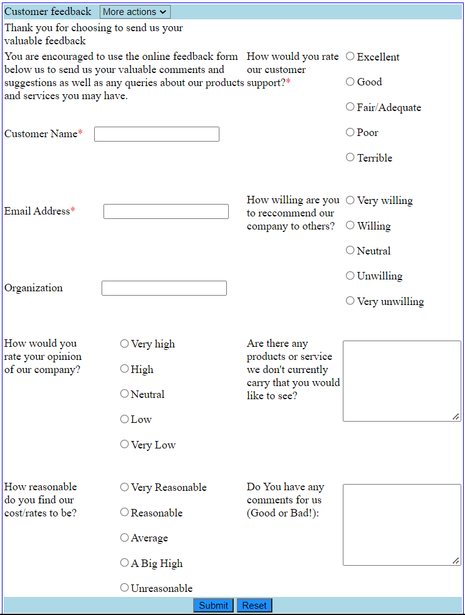

1. Design a train ticket reservation form which includes many components.

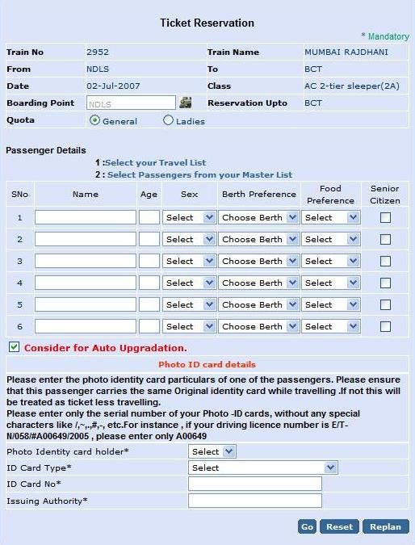

<html>

<style>

***table,td,th***{

border-collapse:collapse***;***

border:2px solid white***;***

}

</style>

<form>

<center>

<table *style*="background-color:lightblue;">

<tr *rowspan*="2" align="center">

<td *style*="border:none;" *colspan*="4"><b>Ticket Reservation</b></td>

</tr>

<tr   align="right">

<td *style*="border:none;" *colspan*="4"><font *color*="green">\* Mandatory</font></td>

</tr>

<tr>

<td *style*="width:200px;"><b>Train No</b></td>

<td *style*="width:200px;">2952</td>

<td *style*="width:200px;"><b>Train Name</b></td>

<td *style*="width:200px;">Mumbai Rajdhani</td>

</tr>

<tr>

<td *style*="width:200px;"><b>From</b></td>

<td *style*="width:200px;">NDLS</td>

<td *style*="width:200px;"><b>To</b><b></b></td>

<td *style*="width:200px;">BCT</td>

</tr>

<tr>

<td *style*="width:200px;"><b>Date</b></td>

<td *style*="width:200px;">02-Jul-2007</td>

<td *style*="width:200px;"><b>Class</b></td>

<td *style*="width:200px;">AC 2-tier sleeper(2A)</td>

</tr>

<tr>

<td *style*="width:200px;"><b><label *for*="boarding">Boarding Point</label></b></td>

<td *style*="width:200px;"><input *type*="text" *name*="boarding" *id*="boarding" *placeholder*="NDLS"></input></td>

<td *style*="width:200px;"><b>Reservation Upto</b></td>

<td *style*="width:200px;">BCT</td>

</tr>

<tr>

<td *style*="width:200px;"><b><label *for*="quota">Quota</label></b></td>

<td *colspan*="3" *style*="width:200px;">

<input *type*="radio" *name*="quota" *id*="quota" *value*="General">General**&emsp;&emsp;&emsp;**</input>

<input *type*="radio" *name*="quota" *id*="quota" *value*="Ladies">Ladies</input>

</td>

</tr>

<tr *rowspan*="4" *style*="height:15px;"><td *style*="border:none;" ></td></tr>

<tr>

<td *colspan*="4" *style*="border:none;"><b>Passenger Details</b></td>

</tr>

<tr>

<td *style*="border:none;"></td>

<td *colspan*="4" *style*="border:none;"><b>1:</b>Select your Travel List</td>

</tr>

<tr>

<td *style*="border:none;"></td>

<td *colspan*="4" *style*="border:none;"><b>2:</b>Select Passengers from your Master list</td>

</tr>

</table>

<table *style*="background-color:lightblue;">

<tr>

<td *style*="width:30px;" align="center">SNo.</td>

<td *style*="width:170px;" align="center">Name</td>

<td *style*="width:50px;" align="center">Age</td>

<td *style*="width:75px;" align="center">Sex</td>

<td *style*="width:160px;" align="center">Berth Preference</td>

<td *style*="width:150px;" align="center">Food Preference</td>

<td *style*="width:140px;" align="center">Senior Citizen</td>

</tr>

<tr>

<td align="center"><label *for*="1">1</label></td>

<td><input *type*="text" *name*="1"></input></td>

<td><input *style*="width:50px;" *type*="text" *name*="1"></input></td>

<td>

<select *style*="width:75px;" *placeholder*="Select">

<option *value*="male">Male</option>

<option *value*="female">Female</option>

<option *value*="Other">Other</option>

</select>

</td>

<td>

<select *style*="width:160px;" *placeholder*="Select">

<option *value*="side lower">Side lower</option>

<option *value*="Side upper">Side upper</option>

<option *value*="Upper">Upper</option>

<option *value*="Lower">Lower</option>

<option *value*="Middle">Middle</option>

</select>

</td>

<td>

<select *style*="width:160px;" *placeholder*="Select">

<option *value*="Non veg">Non Veg</option>

<option *value*="Veg">Veg</option>

</select>

</td>

<td align="center">

<input  *type*="checkbox" >

</td>

</tr>

<tr>

<td align="center"><label *for*="1">2</label></td>

<td><input *type*="text" *name*="1"></input></td>

<td><input *style*="width:50px;" *type*="text" *name*="1"></input></td>

<td>

<select *style*="width:75px;" *placeholder*="Select">

<option *value*="male">Male</option>

<option *value*="female">Female</option>

<option *value*="Other">Other</option>

</select>

</td>

<td>

<select *style*="width:160px;" *placeholder*="Select">

<option *value*="side lower">Side lower</option>

<option *value*="Side upper">Side upper</option>

<option *value*="Upper">Upper</option>

<option *value*="Lower">Lower</option>

<option *value*="Middle">Middle</option>

</select>

</td>

<td>

<select *style*="width:160px;" *placeholder*="Select">

<option *value*="Non veg">Non Veg</option>

<option *value*="Veg">Veg</option>

</select>

</td>

<td align="center">

<input  *type*="checkbox" >

</td>

</tr>

<tr>

<td align="center"><label *for*="1">3</label></td>

<td><input *type*="text" *name*="1"></input></td>

<td><input *style*="width:50px;" *type*="text" *name*="1"></input></td>

<td>

<select *style*="width:75px;" *placeholder*="Select">

<option *value*="male">Male</option>

<option *value*="female">Female</option>

<option *value*="Other">Other</option>

</select>

</td>

<td>

<select *style*="width:160px;" *placeholder*="Select">

<option *value*="side lower">Side lower</option>

<option *value*="Side upper">Side upper</option>

<option *value*="Upper">Upper</option>

<option *value*="Lower">Lower</option>

<option *value*="Middle">Middle</option>

</select>

</td>

<td>

<select *style*="width:160px;" *placeholder*="Select">

<option *value*="Non veg">Non Veg</option>

<option *value*="Veg">Veg</option>

</select>

</td>

<td align="center">

<input  *type*="checkbox" >

</td>

</tr>

<tr>

<td align="center"><label *for*="1">4</label></td>

<td><input *type*="text" *name*="1"></input></td>

<td><input *style*="width:50px;" *type*="text" *name*="1"></input></td>

<td>

<select *style*="width:75px;" *placeholder*="Select">

<option *value*="male">Male</option>

<option *value*="female">Female</option>

<option *value*="Other">Other</option>

</select>

</td>

<td>

<select *style*="width:160px;" *placeholder*="Select">

<option *value*="side lower">Side lower</option>

<option *value*="Side upper">Side upper</option>

<option *value*="Upper">Upper</option>

<option *value*="Lower">Lower</option>

<option *value*="Middle">Middle</option>

</select>

</td>

<td>

<select *style*="width:160px;" *placeholder*="Select">

<option *value*="Non veg">Non Veg</option>

<option *value*="Veg">Veg</option>

</select>

</td>

<td align="center">

<input  *type*="checkbox" >

</td>

</tr>

<tr>

<td align="center"><label *for*="1">5</label></td>

<td><input *type*="text" *name*="1"></input></td>

<td><input *style*="width:50px;" *type*="text" *name*="1"></input></td>

<td>

<select *style*="width:75px;" *placeholder*="Select">

<option *value*="male">Male</option>

<option *value*="female">Female</option>

<option *value*="Other">Other</option>

</select>

</td>

<td>

<select *style*="width:160px;" *placeholder*="Select">

<option *value*="side lower">Side lower</option>

<option *value*="Side upper">Side upper</option>

<option *value*="Upper">Upper</option>

<option *value*="Lower">Lower</option>

<option *value*="Middle">Middle</option>

</select>

</td>

<td>

<select *style*="width:160px;" *placeholder*="Select">

<option *value*="Non veg">Non Veg</option>

<option *value*="Veg">Veg</option>

</select>

</td>

<td align="center">

<input  *type*="checkbox" >

</td>

</tr>

<tr>

<td align="center"><label *for*="1">6</label></td>

<td><input *type*="text" *name*="1"></input></td>

<td><input *style*="width:50px;" *type*="text" *name*="1"></input></td>

<td>

<select *style*="width:75px;" *placeholder*="Select">

<option *value*="male">Male</option>

<option *value*="female">Female</option>

<option *value*="Other">Other</option>

</select>

</td>

<td>

<select *style*="width:160px;" *placeholder*="Select">

<option *value*="side lower">Side lower</option>

<option *value*="Side upper">Side upper</option>

<option *value*="Upper">Upper</option>

<option *value*="Lower">Lower</option>

<option *value*="Middle">Middle</option>

</select>

</td>

<td>

<select *style*="width:160px;" *placeholder*="Select">

<option *value*="Non veg">Non Veg</option>

<option *value*="Veg">Veg</option>

</select>

</td>

<td align="center">

<input  *type*="checkbox" >

</td>

</tr>

</table>

<table *style*="background-color:lightblue;">

<tr>

<td *colspan*="4" *style*="width:812px; height:30px; color:red; border:none;"><input *type*="checkbox"><b>Consider for Auto Upgradation.</b></td>

</tr>

</table >

<table *style*="background-color:lightblue; border:none;">

<tr align="center">

<td *colspan*="4" *style*="width:812px; color:orange; border:none;"><b>Photo ID card details</b></td>

</tr>

<tr>

<td *colspan*="4" *style*="height:100px; width:812px;"><b>Please enter the photo identity card particulars of one of the passengers.Please ensure<br>that this passenger carries the same original identity card while travelling.If not this will<br>be treated as ticket less travelling.<br>Please enter only the serial number of your Photo-ID cards,without any special<br>characters like /,.,#.\*, etc.For insurance,if your driving  licence number is E/T-<br>N/058/#A00649/2005 , please enter only A00649</b>

</td>

</tr>

<tr>

<td *style*="width:400px;">Photo Identity card holder\*</td>

<td>

<select>

<option>select<option>

</select>

</td>

</tr>

<tr>

<td *style*="width:400px;">ID Card Type\*</td>

<td >

<select *style*="width:200px"*;*>

<option>select<option>

</select>

</td>

</tr>

<tr>

<td *style*="width:400px;">ID Card No\*</td>

<td >

<input *type*="text"></input>

</td>

</tr>

<tr>

<td *style*="width:400px;">Issuing Authority\*</td>

<td >

<input *type*="text"></input>

</td>

</tr>

<tr align="right" *style*="height:50px;">

<td *colspan*="2">

<input *type*="submit" *style*="background-color:darkblue; color:white;" *value*="GO">**&ensp;**</input>

<input *type*="submit" *style*="background-color:darkblue; color:white;" *value*="RESET">**&ensp;**</input>

<input *type*="submit" *style*="background-color:darkblue; color:white;" *value*="REPLAN">**&ensp;**</input>

</td>

</tr>

</table>

</center>

</form>

</html>

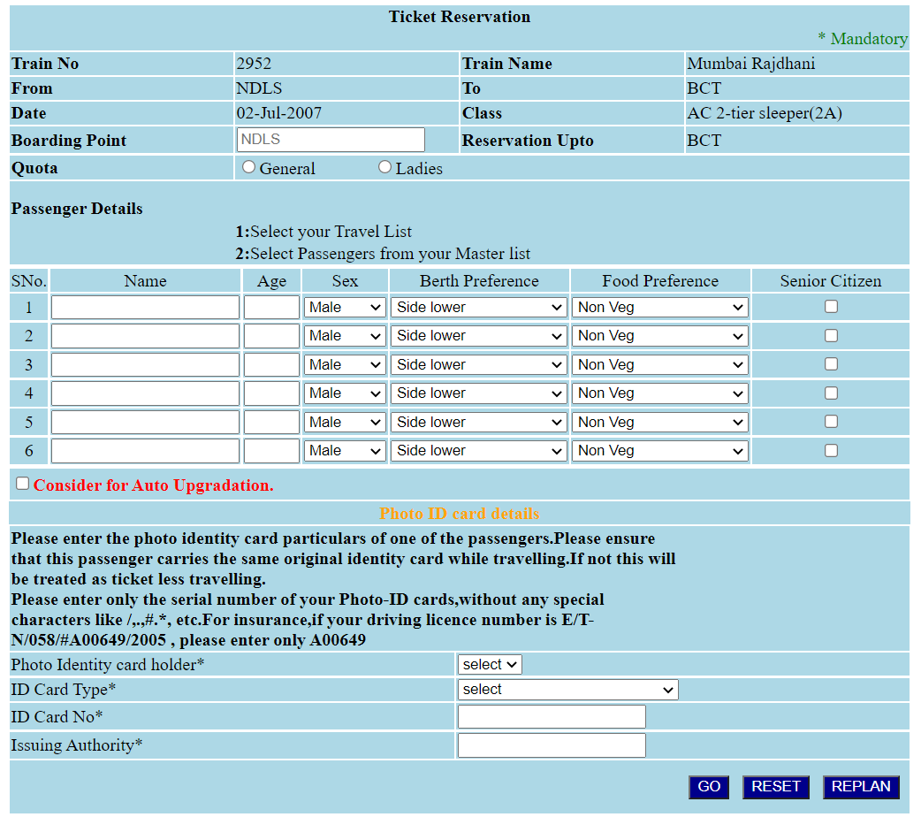

1. Design an event planner which will be helpful in organizing national level competition.

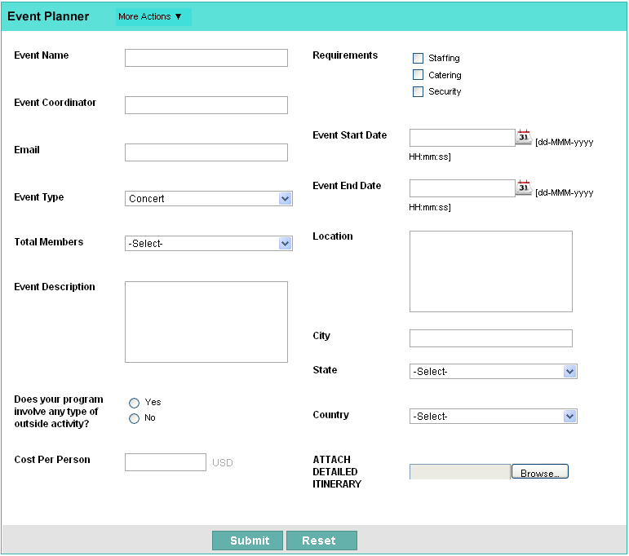

<HTML>

    <form *class*="center" align="center">

    <table align="center" *style*="border:3px lightblue solid;border-collapse: collapse;">

    <tr>

    <td *colspan*="4" *style*="height:30px;width:600px;background-color:lightblue;"><b>Event Planner**&ensp;&ensp;&ensp;**</b><font *size*="2">more actions</font></td>

    </tr>

        <tr *style*="background-color:grey;height:30px;"></tr>

    <tr>

    <td *style*="width:150px;"><label *for*="eventname">Event name</label></td>

    <td *style*="width:150px;"><input *type*="text" *name*="eventname"></input></td>

    <td *style*="width:150px;"><label *for*="req">Requirements</label></td>

    <td *style*="width:150px;"><input *type*="radio" *name*="req" *value*="staff">staff</input></td>

    </tr>

    <tr>

    <td *style*="width:150px;"></td>

    <td *style*="width:150px;"></td>

    <td *style*="width:150px;"></td>

    <td *style*="width:150px;"><input *type*="radio" *name*="req" *value*="staff">staff</input></td>

    </tr>

    <tr>

    <td *style*="width:150px;"></td>

    <td *style*="width:150px;"></td>

    <td *style*="width:150px;"></td>

    <td *style*="width:150px;"><input *type*="radio" *name*="req" *value*="staff">staff</input></td>

    </tr>

    <tr>

    <td *style*="width:150px;"><label *for*="eventco">Event Coordinator</label></td>

    <td *style*="width:150px;"><input *type*="text" *name*="eventco"></td>

    <td *style*="width:150px;"></td>

    <td *style*="width:150px;"></td>

    </tr>

    <tr>

    <td *style*="width:150px;"></td>

    <td *style*="width:150px;"></td>

    <td *style*="width:150px;"><label *for*="stdate">Event Start Date</label></td>

    <td *style*="width:150px;"><input *type*="date" *name*="stdate" *required* *pattern*="\d{4}-\d{2}-\d{2}"><span *class*="validity"></span></td>

    </tr>

    <tr>

    <td *style*="width:150px;"><label *for*="email">Email</label></td>

    <td *style*="width:150px;"><input *type*="text" *name*="email"></input></td>

    <td *style*="width:150px;"></td>

    <td *style*="width:150px;"></td>

    </tr>

    <tr>

    <td *style*="width:150px;"></td>

    <td *style*="width:150px;"></td>

    <td *style*="width:150px;"><label *for*="enddate">Event End Date</label></td>

    <td *style*="width:150px;"><input *type*="date" *name*="enddate" *required* *pattern*="\d{4}-\d{2}-\d{2}"><span *class*="validity"></span></td>

    </tr>

    <tr>

    <td *style*="width:150px;"><label *for*="type">Event type</label></td>

    <td *style*="width:150px;"><Select *style*="width:150px;" *name*="email">

    <option *value*="Concert">Concert</option>

    <option *value*="Dance">Dance</option>

    <option *value*="Singing">Singing</option>

    </select></td>

    <td *style*="width:150px;"></td>

    <td *style*="width:150px;"></td>

    </tr>

    <tr>

    <td *style*="width:150px;"><label *for*="member">Total Members</label></td>

    <td *style*="width:150px;"><Select *style*="width:150px;" *placeholder*="-select-" *name*="member">

    <option *value*="2">2</option>

    <option *value*="3">3</option>

    <option *value*="4">4</option>

    </select></td>

    <td *style*="width:150px;"><label *for*="location">Location</label></td>

    <td *style*="width:150px;"><textarea *id*="location" *name*="location" *rows*="4" *cols*="30"></textarea></td>

    </tr>

    <tr>

    <td *style*="width:150px;"><label *for*="descr">Event Description</label></td>

    <td *style*="width:150px;"><textarea *id*="location" *name*="location" *rows*="4" *cols*="30"></textarea></td>

    <td *style*="width:150px;"><label *for*="city">City</label></td>

    <td *style*="width:150px;"><input *type*="text" *name*="city"></input></td>

    </tr>

    <tr>

    <td *style*="width:150px;"></td>

    <td *style*="width:150px;"></td>

    <td *style*="width:150px;"><label *for*="state">State</label></td>

    <td *style*="width:150px;"><Select *style*="width:150px;" *name*="state">

    <option *value*="tn">TN</option>

    <option *value*="ka">KA</option>

    <option *value*="AP">Ap</option>

    </select></td>

    </tr>

    <tr>

    <td *style*="width:150px;"><label *for*="qoo">Does your program<br>involve any type of<br>outside activity?</label></td>

    <td *style*="width:150px;"><input *type*="radio" *name*="req" *value*="yes">Yes</input><br><input *type*="radio" *name*="req" *value*="no">No</input></td>

    <td *style*="width:150px;"><label *for*="country">Country</label></td>

    <td *style*="width:150px;"><Select *style*="width:150px;" *name*="state">

    <option *value*="India">India</option>

    <option *value*="Sri lanka">Sri lanka</option>

    <option *value*="Singapore">Singapore</option>

    </select></td>

    </tr>

    <tr></tr>

    <tr>

    <td *style*="width:150px;"><label *for*="cpp">Cost Per Person</label></td>

    <td *style*="width:150px;"><input *type*="text" *name*="cpp" *value*="USD">USD</input></td>

    <td *style*="width:150px;"><label *for*="ADI">ATTACH<br>DETAILED<br>ITINERARY</label></td>

    <td *style*="width:150px;"><input *type*="text" *name*="ADI"></input><button *type*="button" *onclick*="*alert*('Hello world!')">Browse</button></td>

    </tr>

    <tr *style*="background-color:grey;height:50px;">

        <td></td>

        <td *style*="text-align:right;"><button *style*="border:none;background-color:lightblue;color:white;height:30px;width:80px;">Submit</button></td>

        <td><button *style*="border: none;background-color:lightblue;color:white;height:30px;width:80px;">Reset</button></td>

        <td></td>

    </tr>

    </table>

    </form>

    </HTML>

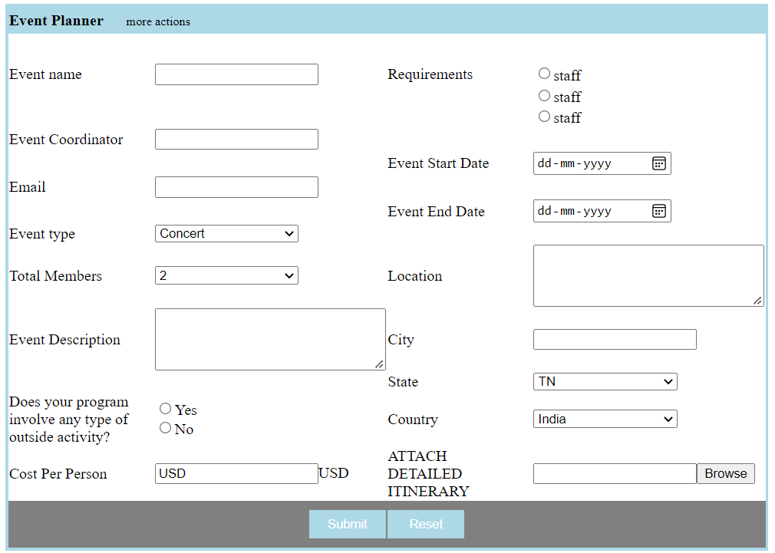

1. Design a form for online accommodation booking system.

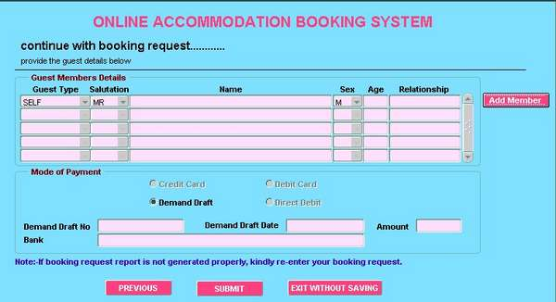

<html>

<form>

<center>

<table  bgcolor="cyan">

<tr>

<td *colspan*="6" align="center"><font *face*="arial" *color*="red"><h2>ONLINE ACCOMMODATION BOOKING SYSTEM</h2></font></td>

</tr>

<tr  *style*="height:20px">

<td *colspan*="6" align="left"> <font *size*="4">**&emsp;**<b>continue with booking request..........</b></font></td>

</tr>

<tr>

<td *colspan*="6" align="left">**&emsp;**provide the guest details below</td>

</tr>

<tr>

<td *colspan*="6" align="left"><hr *color*="black" *style*="width:90%;"></td>

</tr>

<tr>

<td>

<fieldset>

<legend><font *color*="brown"><b>Guest Members Details</b></font></legend>

<table align="center">

</tr>

<td align="center"><b>Guest Type</b></td>

<td align="center"><b>Salutation</b></td>

<td align="center"><b>Name</b></td>

<td align="center"><b>Sex</b></td>

<td align="center"><b>Age</b></td>

<td align="center"><b>Relationship</b></td>

</tr>

<tr>

<td>

<select *style*="width:80px; background-color:pink">

<option>Self</option>

</select>

</td>

<td>

<select *style*="width:80px; background-color:pink">

<option>MR</option>

<option>MS</option>

</select>

</td>

<td>

<input *style*="background-color:pink;" *type*="text"></input>

</td>

<td>

<select *style*="width:50px; background-color:pink">

<option>M</option>

<option>F</option>

<option>Other</option>

</select>

</td>

<td>

<input *style*="width:50px; background-color:pink;" *type*="text"></input>

</td>

<td>

<input *style*="width:100px; background-color:pink;" *type*="text"></input>

</td>

</tr>

<tr>

<td>

<select *style*="width:80px; background-color:pink">

<option>Self</option>

</select>

</td>

<td>

<select *style*="width:80px; background-color:pink">

<option>MR</option>

<option>MS</option>

</select>

</td>

<td>

<input *style*="background-color:pink;" *type*="text"></input>

</td>

<td>

<select *style*="width:50px; background-color:pink">

<option>M</option>

<option>F</option>

<option>Other</option>

</select>

</td>

<td>

<input *style*="width:50px; background-color:pink;" *type*="text"></input>

</td>

<td>

<input *style*="width:100px; background-color:pink;" *type*="text"></input>

</td>

</tr>

<tr>

<td>

<select *style*="width:80px; background-color:pink">

<option>Self</option>

</select>

</td>

<td>

<select *style*="width:80px; background-color:pink">

<option>MR</option>

<option>MS</option>

</select>

</td>

<td>

<input *style*="background-color:pink;" *type*="text"></input>

</td>

<td>

<select *style*="width:50px; background-color:pink">

<option>M</option>

<option>F</option>

<option>Other</option>

</select>

</td>

<td>

<input *style*="width:50px; background-color:pink;" *type*="text"></input>

</td>

<td>

<input *style*="width:100px; background-color:pink;" *type*="text"></input>

</td>

</tr>

<tr>

<td>

<select *style*="width:80px; background-color:pink">

<option>Self</option>

</select>

</td>

<td>

<select *style*="width:80px; background-color:pink">

<option>MR</option>

<option>MS</option>

</select>

</td>

<td>

<input *style*="background-color:pink;" *type*="text"></input>

</td>

<td>

<select *style*="width:50px; background-color:pink">

<option>M</option>

<option>F</option>

<option>Other</option>

</select>

</td>

<td>

<input *style*="width:50px; background-color:pink;" *type*="text"></input>

</td>

<td>

<input *style*="width:100px; background-color:pink;" *type*="text"></input>

</td>

</tr>

<tr>

<td>

<select *style*="width:80px; background-color:pink">

<option>Self</option>

</select>

</td>

<td>

<select *style*="width:80px; background-color:pink">

<option>MR</option>

<option>MS</option>

</select>

</td>

<td>

<input *style*="background-color:pink;" *type*="text"></input>

</td>

<td>

<select *style*="width:50px; background-color:pink">

<option>M</option>

<option>F</option>

<option>Other</option>

</select>

</td>

<td>

<input *style*="width:50px; background-color:pink;" *type*="text"></input>

</td>

<td>

<input *style*="width:100px; background-color:pink;" *type*="text"></input>

</td>

</tr>

</table>

</fieldset>

</td>

<td>

    <input *type*="button" *style*="color:white; background-color:#c91377;" *value*="ADD MEMBER">**&emsp;**</input>

</td>

</tr>

<tr>

<td>

<fieldset>

<legend><font *color*="brown"><b>Mode of payment</b></font></legend>

<table align="center">

<tr>

<td>

<label *for*="pay">

<input *type*="radio" *name*="pay" *value*="pay">Credit Card</input>

</td>

<td>

<label *for*="pay">

<input *type*="radio" *name*="pay" *value*="pay">Debit Card</input>

</td>

</tr>

<tr>

<td>

<label *for*="pay">

<input *type*="radio" *name*="pay" *value*="pay">Demand Draft</input>

</td>

<td>

<label *for*="pay">

<input *type*="radio" *name*="pay" *value*="pay">Direct Debit</input>

</td>

</tr>

</table>

<table>

<tr>

<td>

<label *for*="DDno"><b>**&emsp;**Demand Draft No</b></label>

</td>

<td>

<input *type*="text" *name*="DDno"></input>

</td>

<td>

<label *for*="DDdt"><b>**&emsp;**Demand Draft Date</b></label>

</td>

<td>

<input *type*="text" *name*="DDdt"></input>

</td>

<td>

<label *for*="Amt"><b>**&emsp;**Amount</b></label>

</td>

<td>

<input *type*="text" *name*="Amt"></input>

</td>

</tr>

<tr>

<td>

<label *for*="Bank"><b>**&emsp;**Bank</b></label>

</td>

<td>

<input *type*="text" *style*="width:293%;" *name*="Bank"></input>

</td>

</tr>

</table>

</fieldset>

</td>

</tr>

<tr>

<td *style*="height:40px;"><font *color*="blue"><b>**&emsp;**Note:If booking request report is not generated properly, kindly re-enter your booking request.</b></font></td>

</tr>

<tr align="center">

    <td *style*="height:40px;">

        <input *type*="button" *style*="color:white; background-color:#c91377;" *value*="PREVIOUS">**&emsp;**</input>

        <input *type*="button" *style*="color:white; background-color:#c91377;" *value*="SUBMIT">**&emsp;**</input>

        <input *type*="button" *style*="color:white; background-color:#c91377;" *value*="EXIT WITHOUT SAVING">**&emsp;**</input>

    </td>

</tr>

</table>

</center>

</form>

</html>

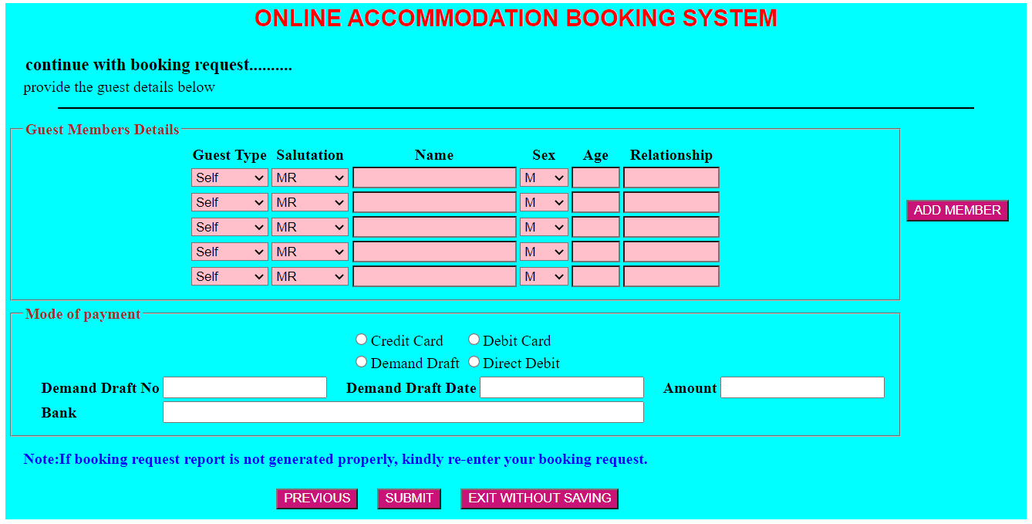

**Note:**

**From questions 6-10 students are requested to create design specification and then do designing the web page.**

1. Design the web form for uploading recipe. Accept images

<html>

<body bgcolor="#47c979">

  <style>

    textarea {

    width: 500px;

    height: 200px;

}

  </style>

<h1 align="center">Recepies</h1>

<form action="upload.php" method="post" enctype="multipart/form-data">

  Select image to upload:

  <input type="file" name="fileToUpload" id="fileToUpload">

  <input type="submit" value="Upload Image" name="submit">

  <br><br><br>

  <label for="fname">Food name :</label>

<input type="text" id="fname" name="fname">

<br><br><br>

<label for="ftype">Food type :</label>

<br><br>

<input type="radio" id="south" name="ftype">South Indian

<br><br>

<input type="radio" id="north" name="ftype">North Indian

<br><br>

<input type="radio" id="Chinese" name="ftype">Chinese

<br><br>

<input type="radio" id="multi" name="ftype">Multi cuisine

<br><br>

<input type="radio" id="others" name="ftype">Others

<br><br><br>

<label for="descrp">Food Description : </label>

<br><br>

<textarea></textarea>

</form>

</body>

</html>

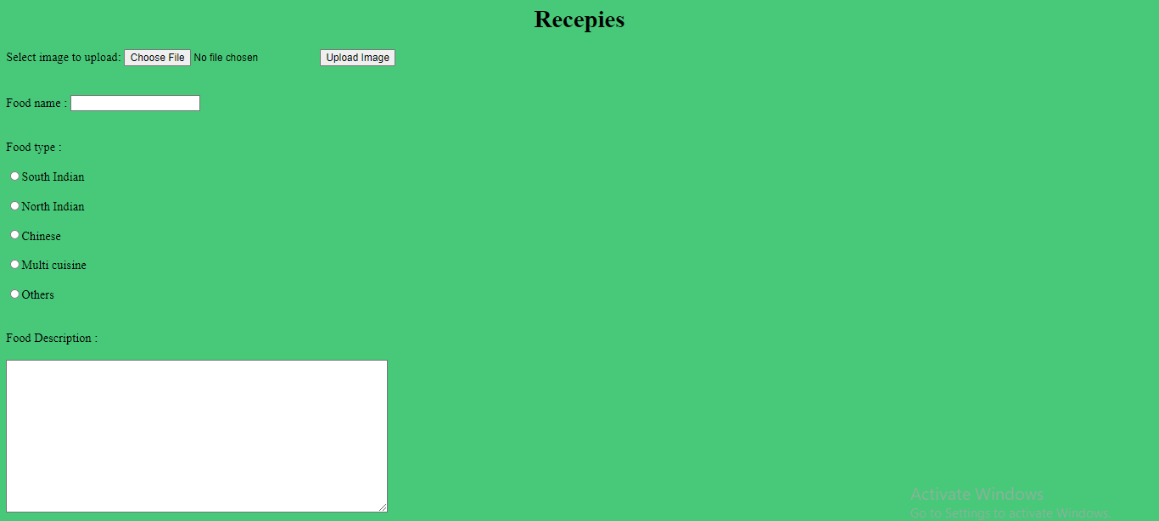

1. A recruitment agency wants to accept applications online from its applicant. Design web page(s) for the applicant to upload their bio-data.

<html>

<head>

<font size="12"><b><center>BIO DATA</center></b></font>

</head>

<style>

td{padding:1em;}

</style>

<form>

<table align="center" bgcolor="orange" cellspacing="20px" style="border-collapse:collapse;">

    <tr>

        <td colspan="6" align="center">Complete the information in the form below and click on the next button to continue.Required <br>fields are indicated with an asterik(\*).</td>

    </tr>

    <tr style="height:60px;">

            <td><label for="fname">First Name\*</label></td>

            <td><input type="text"></input></td>

            <td align="right"><label for="mi">Middle Initial</label></td>

            <td><input type="text"></input></td>

            <td><label for="mi">Last Name</label></td>

            <td><input type="text"></input></td>

    </tr>

    <tr style="height:60px;">

                <td><label for="dob"> Date of Birth</label></td>

                <td><input  type="date"></input></td>

                <td align="right"><label for="SSN">SSN</label></td>

                <td><input type="text"></input></td>

    </tr>

    <tr style="height:60px;">

        <td><label for="12th">12th percentage</label></td>

        <td><input type="text"></input></td>

        <td align="right"><label for="yop">Year of Passing</label></td>

        <td><input type="text"></input></td>

    </tr>

    <tr style="height:60px;">

        <td><label for="occupation">Graduation</label></td>

        <td><input type="text"></input></td>

        <td align="right"><label for="yop">Year of Passing</label></td>

        <td><input type="text"></input></td>

    </tr>

    <tr style="height:60px;">

        <td><label for="pl">Primary Language</label></td>

        <td><input type="text"></input></td>

        <td><label for="sl">Secondary Language</label></td>

        <td><input type="text"></input></td>

    </tr>

    <tr  style="height:60px;">

        <td><label for="Gender">Gender\*</label></td>

        <td><select><option>Male</option><option>Female</option></select></td>

        <td align="right"><label for="yop">Martial Status</label></td>

        <td><select><option>Male</option><option>Female</option></select></td>

    </tr>

    <tr style="height:60px;">

        <td><label for="h">Height</label></td>

        <td><input type="text"></input></td>

        <td align="right"><label for="w">Weight</label></td>

        <td><input type="text"></input></td>

    </tr>

    <tr style="height:60px;">

        <td><label for="noc">No of Children</label></td>

        <td><input type="text"></input></td>

        <td><input type="button" value="cancel"></input></td>

        <td><input type="button" value="Next(1 of 8)"></input></td>

        <td><input type="button" value="Done"></input></td>

    </tr>

</table>

</form>

</html>

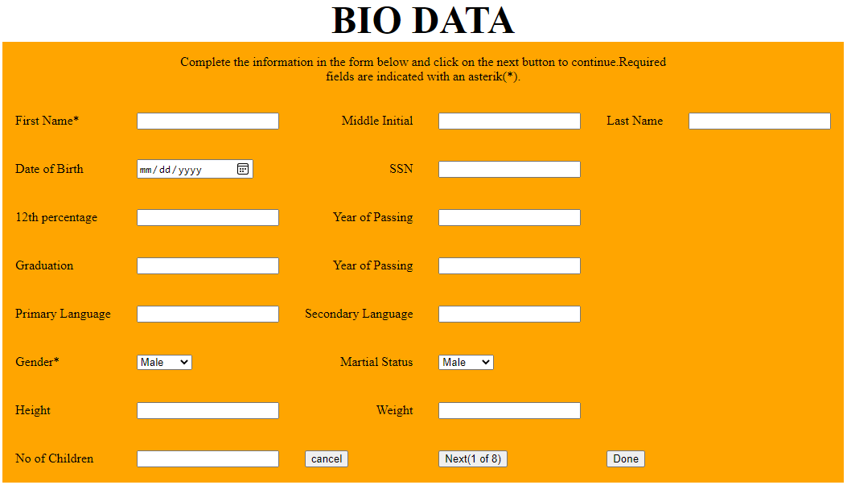

1. Design student online leave application form. (Refer intranet web site)

<html>  
<style>  
 th,td {  
 height:30px;  
 width:800px;  
 }  
</style>  
<body bgcolor="lightblue">  
<h1 align="center">LEAVE ENTRY FORM</h1>  
<table align="center">  
 <tr bgcolor="pink">  
 <td colspan="2"><label for="rollno">Roll No:</label></td>  
 <td align="center" colspan="2"><input type="text" name="rollno"></td>  
 </tr>  
  
 <tr bgcolor="pink">  
 <td colspan="2"><label for="name">Name:</label></td>  
 <td align="center" colspan="2"><input type="text" name="name"></td>  
 </tr>  
 <tr bgcolor="pink">  
 <td colspan="2"><label for="prog">Course:</label></td>  
 <td align="center" colspan="2"><input type="text" name="prog"></td>  
 </tr>  
 <tr style="height:30px;"></tr>  
 <tr bgcolor="pink">  
 <td style="width:100;"><label for="st">Start date:</label></td>  
 <td align="center" style="width:100;"><input type="date" name="st" required pattern="\d{4}-\d{2}-\d{2}"><span class="validity"></span></td>  
 <td style="width:100;"><label for="end">End date:</label></td>  
 <td align="center" style="width:100;"><input type="date" name="end" required pattern="\d{4}-\d{2}-\d{2}"><span class="validity"></span></td>  
 </tr>  
 <tr bgcolor="pink">  
 <td colspan="2"><label for="leave">Leave type:</label></td>  
 <td align="center" colspan="2"><Select style="width:150px;" name="email">  
 <option value="Leave">Leave</option>  
 <option value="Medication">Medication</option>  
 <option value="Exemption">Exemption</option>  
 </select></td>  
 </tr>  
 <tr bgcolor="pink">  
 <td colspan="2"><label for="reason">Reason:</label></td>  
 <td align="center" colspan="2"><input type="text" name="reason"></td>  
 </tr>  
</table>  
<br>  
<br>  
<table align="center">  
 <tr bgcolor="pink">  
 <td colspan="2" style="text-align:right;"><label for="daytype">Day type:</label></td>  
 <td colspan="2"><Select style="width:150px;" name="email">  
 <option value="Half day">Half day</option>  
 <option value="Full day">Full day</option>  
 <option value="Continous day">Contionous day</option>  
</select></td>  
 </tr>  
 <tr style="height:30px;" bgcolor="lightblue"></tr>  
 <tr bgcolor="pink">  
 <td style="width:100;text-align:right;"><label for="date">Date:</label></td>  
 <td style="width:100;"><input type="date" name="date" required pattern="\d{4}-\d{2}-\d{2}"><span class="validity"></span></td>  
 <td style="width:100;text-align:right;"><label for="session">Session:</label></td>  
 <td style="width:100;"><Select style="width:150px;" name="session">  
 <option value="Forenoon">Forenoon</option>  
 <option value="Afternoon">Afternoon</option>  
 </select></td>  
 </tr>  
</table>  
<br>  
<br>  
<br>  
<table align="center" bgcolor="pink">  
 <tr>  
 <td style="text-align:right;"><button style="border:none;">Apply</button></td>  
 <td><button style="border:none;">Clear</button></td>  
 </tr>  
</table>  
</body>  
</html>

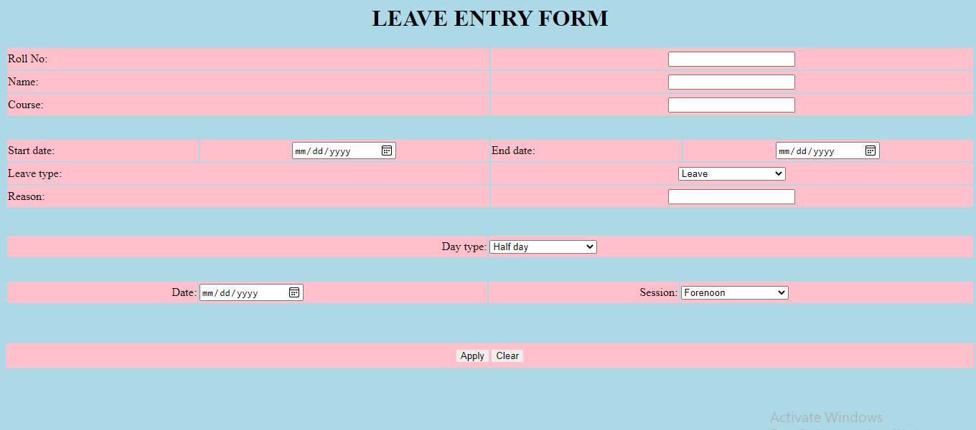

1. Design form for user registration process in an online banking.

<html>

    <style>

        Table{

            width:70%;

        border:1px solid blue;

        border-collapse: collapse;

      }

    </style>

    <body>

        <title>Banking form</title>

        <table align="center">

            <tr style="background-color: lightblue;">

                <td colspan="2">Online banking &nbsp;

                      <select style="background-color: lightblue;" name="More actions" id="More actions">

                        <option value="More actions">More actions</option>

                      </select>

                    </td>

                </tr>

    <tr  height="50px">

    <td>

    <label for="date"><b>Date</b></label>

    </td>

    <td>

        <input type="date" id="date" name="date">

    </td></tr>

    <tr  height="50px">

        <td ><label for="cate"><b>Category</b></label></td>

        <td>

            <select>

            <option>-select-</option>

            </select>

        </td>

    </tr>

    <td><label for="cate"><b>Subcategory</b></label></td>

    <td>

        <select>

        <option>-select-</option>

        </select>

    </td>

    <tr  height="50px">

        <td><label for="payee"><b>Payee</b></label></td>

    <td>

        <select>

        <option>-select-</option>

        </select>

    </td>

    </tr>

    <tr  height="50px">

        <td>

            <label for="amt"><b>Amount</b></label>

        </td>

        <td>

            <input type="text">

        </td>

    </tr>

    <tr  height="50px">

        <td><label for="method"><b>Payment Method</b></label></td>

    <td>

        <select>

        <option>-select-</option>

        </select>

    </td>

    </tr>

    <tr  height="50px">

        <td><label for="tx"><b>Transaction note</b></label></td>

    <td>

        <textarea style="height: 100px; width: 200px;"></textarea>

    </td>

    </tr>

    <tr  height="100px">

        <td></td>

    </tr>

    <tr style="background-color: lightblue;">

        <td align="center" colspan="2">

            <button>submit</button>

            <button>reset</button>

        </td>

        </table>

    </body>

</html>

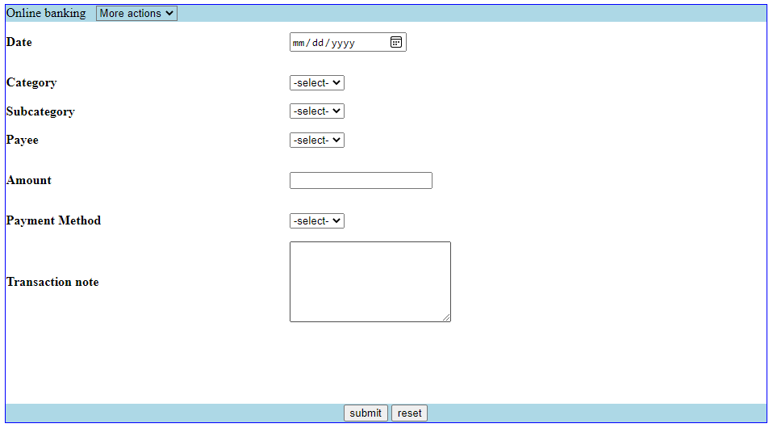

1. Design a form for posting bug report in a peer group.

<html>

    <head>

        <title>bug report</title>

    </head>

     <body align="center">

    <center>

        <form>

            <font face="verdana">

            <fieldset style="width: 35%;">

                <legend><h2><b>BUG REPORT FORM</b></h2></legend>

            <table style="padding: 25px;" bgcolor = "#dba7c5">

                <tr>

                    <td colspan="2">

                        <b>Report a new bug.</b>

                    </td>

                </tr>

                <tr>

                    <td colspan="2">

                        <i>This bug report form is designed for a peer group that wants to provide<br> its customer service representatives and quality assurance team with a <br>tool to file software bugs with comprehensive details.

                        <br>This way, developers  can quickly review and fix those bugs.</i>

                    </td>

                </tr>

                <tr>

                    <td colspan="2">

                        <hr color="black" style="width:85%; height:1px">

                    </td>

                </tr>

                <tr>

                    <td colspan="2" height="20px"></td>

                </tr>

                <tr>

                    <td><label for="name">Submitted by</label><br><input type="text" id="name"></td>

                    <td><label for="date">Date</label><br><input type="date" id="date"></td>

                </tr>

                <tr>

                    <td colspan="2"><label for="title">Bug Title</label><br><input type="text" id="title"></td>

                </tr>

                <tr>

                    <td colspan="2">

                        <label for="summary">Issue Description</label><br>

                        <textarea name="summary" id="summary" cols="58" rows="10"></textarea>

                    </td>

                </tr>

                <tr>

                    <td>

                        <label for="os">Operating system</label><br>

                        <select name="os" id="os">

                            <option value="windowsXP">Windows XP</option>

                            <option value="windows7">Windows 7</option>

                            <option value="windows8">Windows 8</option>

                            <option value="windows10">Windows 10</option>

                            <option value="MacOs">MacOs</option>

                        </select>

                    </td>

                    <td>

                        <label for="bs">Browser</label><br>

                        <select name="bs" id="bs">

                            <option value="Firefox">Firefox</option>

                            <option value="chrome">Google chrome</option>

                            <option value="explorer">Explorer</option>

                            <option value="edge">Microsoft Edge</option>

                        </select>

                    </td>

                </tr>

                <tr>

                    <td colspan="2">

                        <h4>Screenshots demonstrating bug's behaviour</h4>

                    </td>

                </tr>

                <tr>

                    <td>

                        <label for="ss1">Screenshot 1</label><br>

                        <input type="file" id="ss1">

                    </td>

                    <td>

                        <label for="ss2">Screenshot 2</label><br>

                        <input type="file" id="ss2">

                    </td>

                </tr>

                <tr>

                    <td colspan="2">

                        <h4>Additional Information</h4>

                    </td>

                </tr>

                <tr>

                    <td>

                        <b>Report View Status</b>

                        <br>

                        <input type="radio" name="rvs" id="public"><label for="public">Public</label>

                        <br>

                        <input type="radio" name="rvs" id="private"><label for="private">Private</label>

                    </td>

                    <td>

                        <b>Reproducibility</b>

                        <br>

                        <input type="radio" name="r" id="ao"><label for="ao">Always Occurs</label>

                        <br>

                        <input type="radio" name="r" id="io"><label for="io">Intermittently Occurs</label>

                    </td>

                </tr>

                <tr>

                    <td colspan="2" height="15px"></td>

                </tr>

                <tr>

                    <td>

                        <b>Severity</b>

                        <br>

                        <input type="radio" name="s" id="c"><label for="c">Critical</label>

                        <br>

                        <input type="radio" name="s" id="h"><label for="h">High</label>

                        <br>

                        <input type="radio" name="s" id="m"><label for="m">Medium</label>

                        <br>

                        <input type="radio" name="s" id="l"><label for="l">Low</label>

                    </td>

                    <td>

                        <b>Priority</b>

                        <br>

                        <input type="radio" name="p" id="c"><label for="c">Critical</label>

                        <br>

                        <input type="radio" name="p" id="h"><label for="h">High</label>

                        <br>

                        <input type="radio" name="p" id="m"><label for="m">Medium</label>

                        <br>

                        <input type="radio" name="p" id="l"><label for="l">Low</label>

                    </td>

                </tr>

                <tr>

                    <td colspan="2" height="15px"></td>

                </tr>

                <tr>

                    <td colspan="2">

                        <label for="status">Status&nbsp;&nbsp;&nbsp;&nbsp;&nbsp;&nbsp;</label>

                        <select name="" id="status">

                            <option value="inq">In Queue</option>

                            <option value="inp">In Progress</option>

                            <option value="Resolved">Resolved</option>

                        </select>

                    </td>

                </tr>

                <tr>

                    <td colspan="2" height="15px"></td>

                </tr>

                <tr>

                    <td align="center" colspan="2">

                        <input type="submit">

                    </td>

                </tr>

            </table>

            </fieldset>

            </font>

        </form>

    </body>

</html>

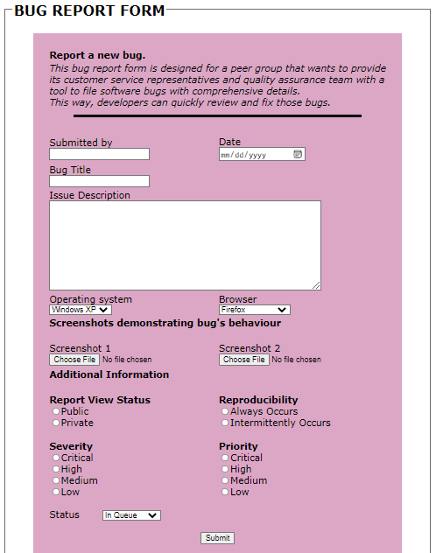

**Note: Students can have a look at the following pages [6-16] for sample web design using HTML form element.**

**Sample HTML Form Designs**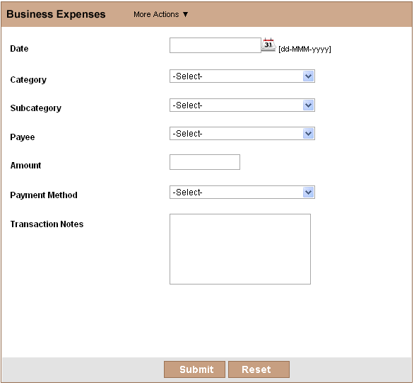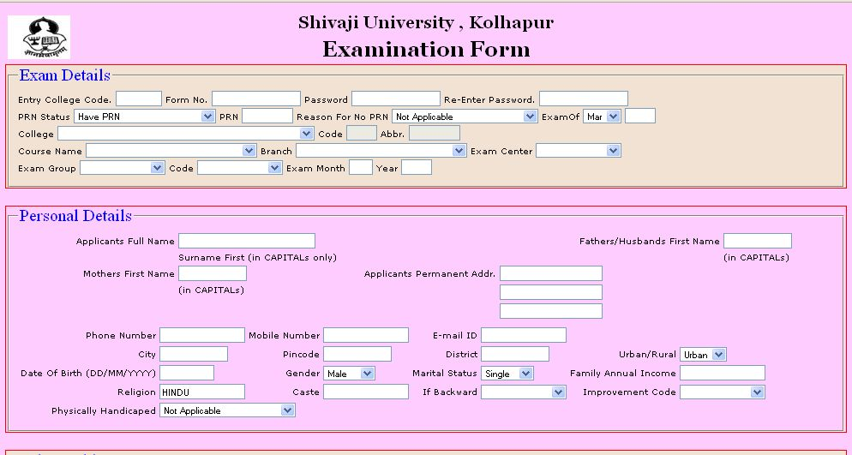

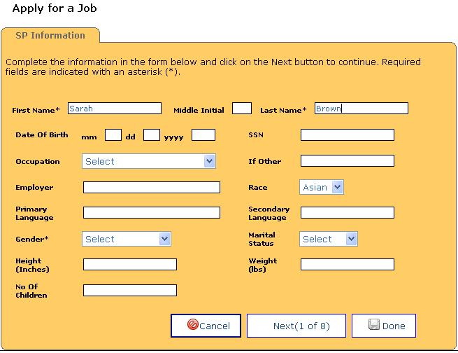

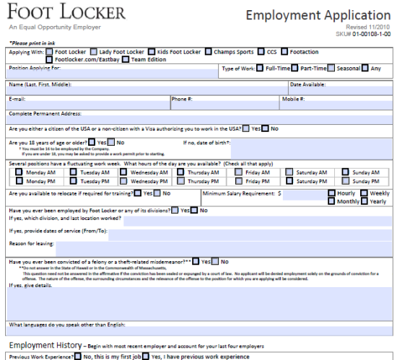

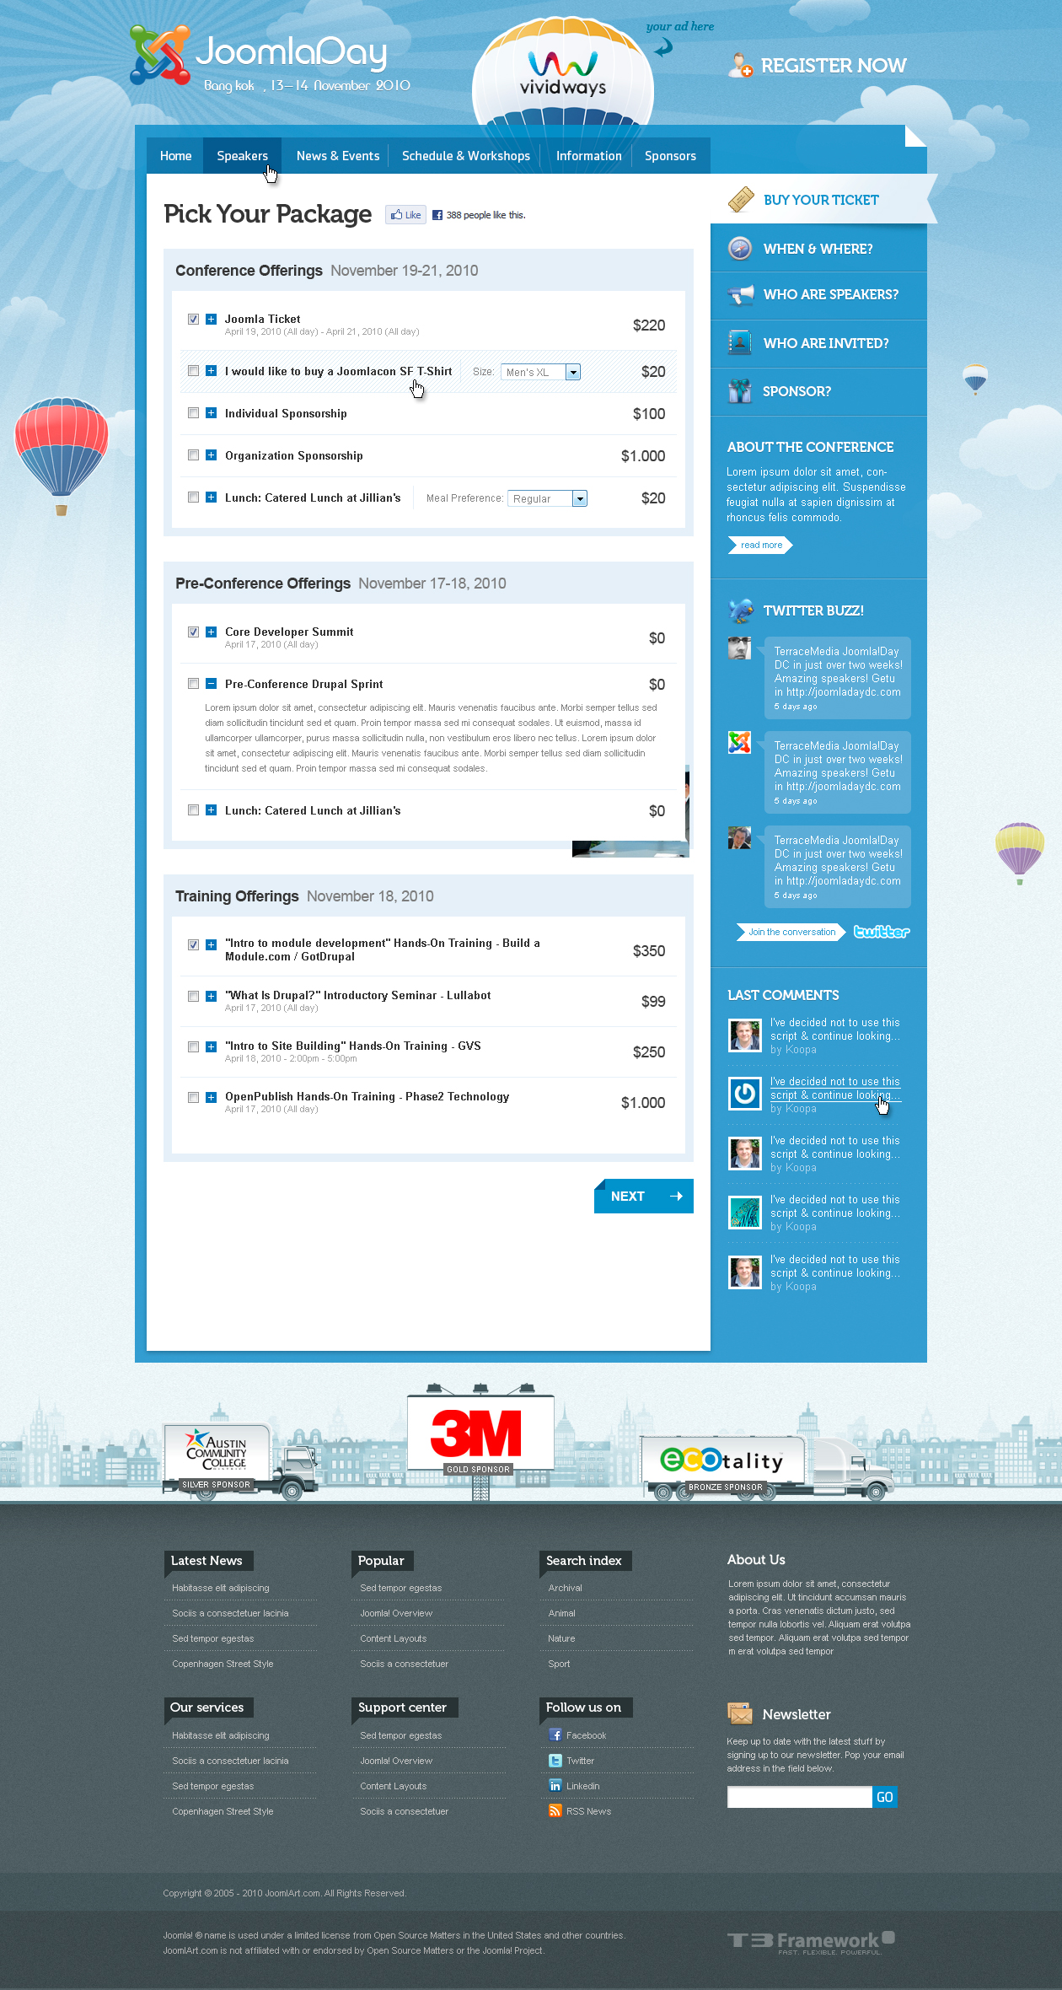

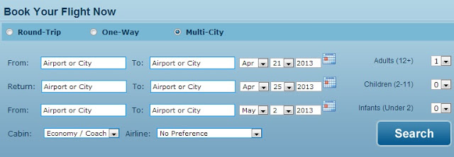

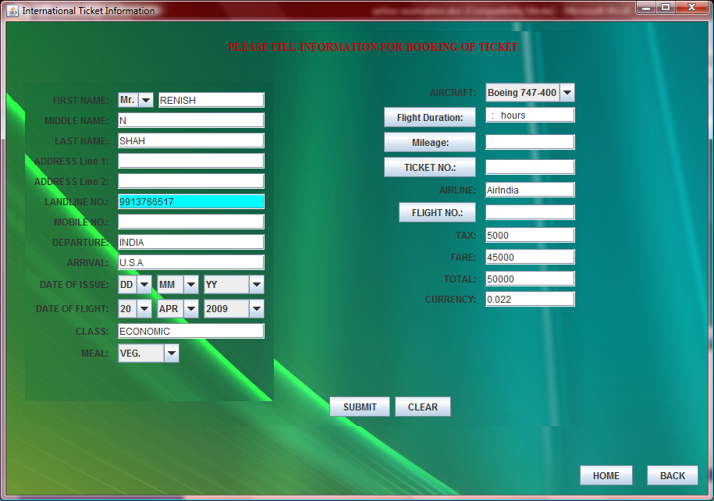

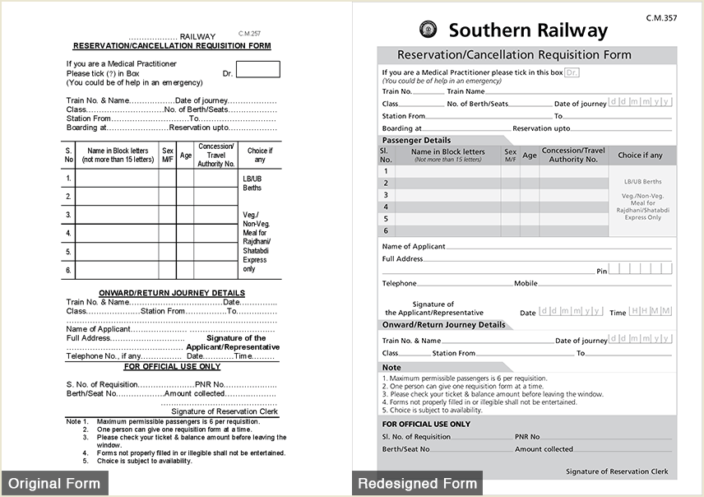

1. Create an order form as shown below.

|  |  |
| --- | --- |
|  | |
|  | |
|  |  |
|  |  |
|  | |
|  | |

|  |
| --- |
|  |
| http://www.zoho.com/creator/images/subpages/htmlforms/time_sheet.gif  http://www.zoho.com/creator/images/subpages/htmlforms/cancellation_survey.gif  http://www.zoho.com/creator/help/images/field-note.png  C:\Documents and Settings\Anandhi\Desktop\contact_manager.gif |